**KMS, SSM PARAMETER STORE, SHIELD & WAF**

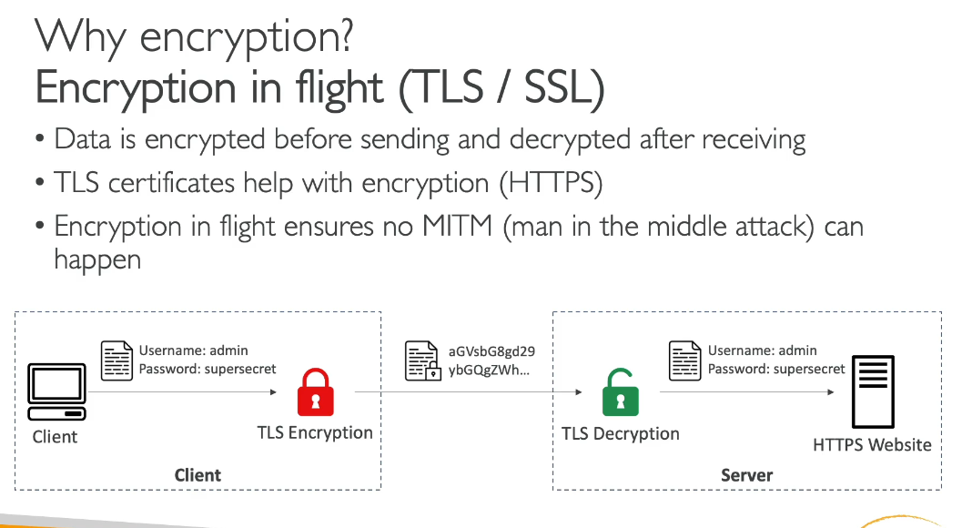

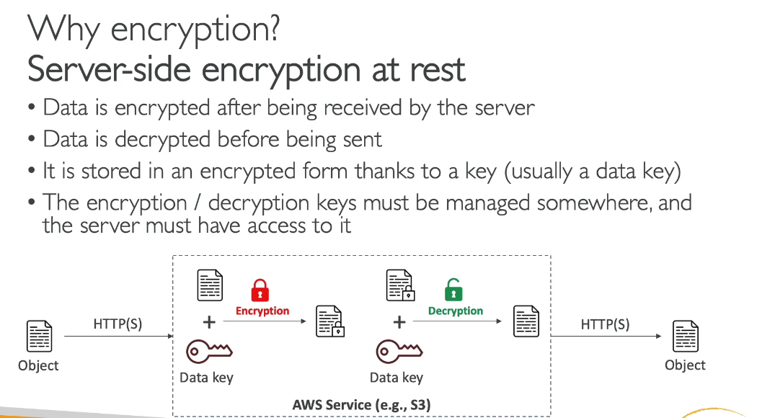

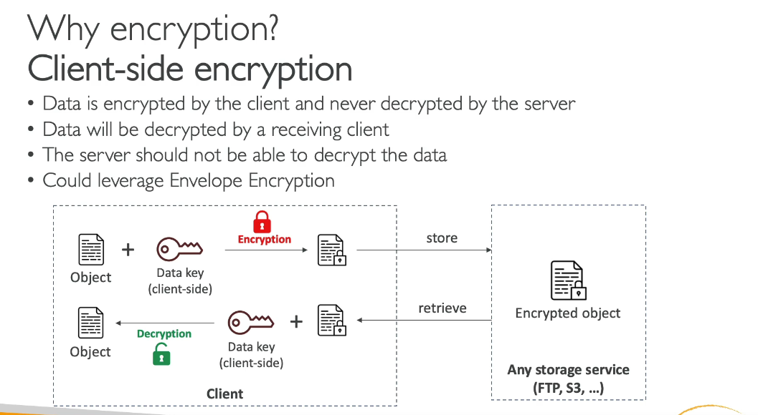

KMS:

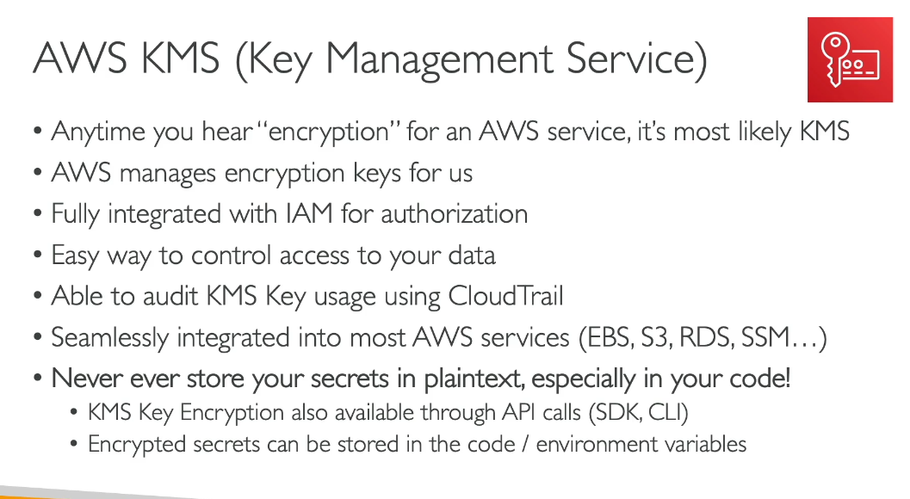

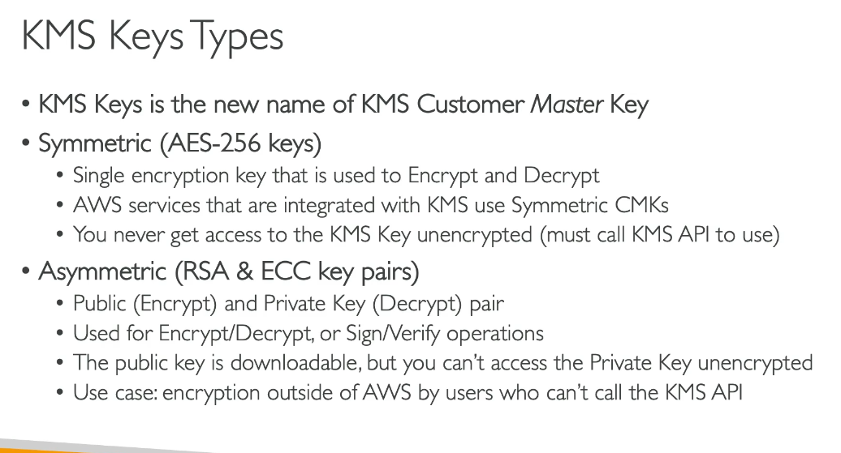

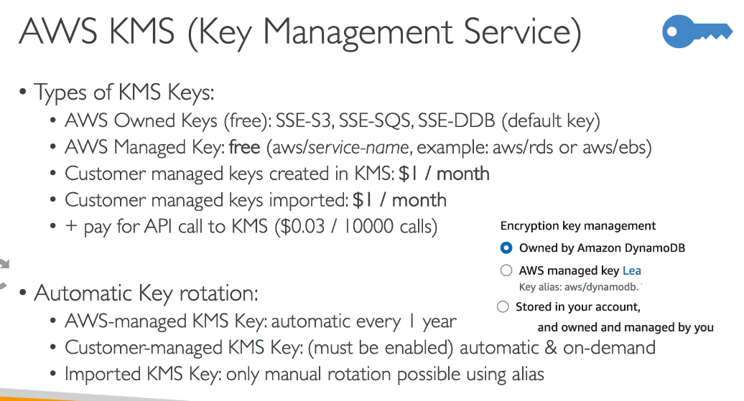

# **AWS Owned Keys**

**What it is:**  
 Keys fully owned and controlled by AWS. They live in AWS’ KMS backend. You never see them, can’t rotate them, can’t audit them, can’t use them outside their service.

**Cost:** Free.

**Example:**

* You enable S3 encryption with **SSE-S3 (AES-256)**. AWS encrypts your objects without asking you anything.
* Same for **SSE-SQS**, **SSE-DDB** default encryption.

**Use case:**  
 ✔️ “I don’t give a shit about key management. I just want encryption so compliance stops yelling at me.”  
 ❌ Not good if you need key lifecycle control or regulatory audit/logging.

**Ideal for:**  
 Non-critical data, internal workloads, quick setup, low compliance requirements.

# **AWS Managed Keys (AWS-Managed CMK)**

**What it is:**  
 A key *AWS creates for you*, but you don’t manage it. AWS rotates it every year automatically. You can see it in KMS, but control is minimal.

**Cost:** Free for the key, you still pay for API calls to KMS.

**Example:**

* You enable encryption on RDS with aws/rds key.
* You enable EBS encryption with aws/ebs.
* You check CloudTrail and see AWS is using a CMK on your behalf.

**Use case:**  
 ✔️ “I need something more visible than AWS-owned but I don’t want to fucking manage key policies and rotation.”  
 ❌ Not for strict compliance like PCI-DSS/HIPAA where auditors expect key ownership.

**Ideal for:**  
 Production workloads that need auditability but not deep security controls.

# **Customer Managed Keys (CMK you create in KMS)**

**What it is:**  
 You own the key. You define:

* IAM permissions (who can use it to encrypt/decrypt)
* Rotation (you can enable auto-rotation)
* Deletion schedule
* Key policies
* Logging & auditing

**Cost:** $1/month per key + KMS API request charges.

**Example:**

* You create myapp-prod-kms-key and attach it to:
  + S3 buckets for sensitive logs
  + EKS Secrets Encryption
  + Lambda environment variables
  + Parameter Store (SecureString)

**Use case:**  
 ✔️ “I have security/compliance people who will punch me if I don’t prove key control.”  
 ✔️ “I need cross-account share or multi-region replication.”  
 ❌ Too much overhead for simple apps.

**Ideal for:**  
 Regulated industries, anything with customer PII, multicloud or complex security requirements.

# **Customer Imported Keys**

**What it is:**  
 You generate the key material outside AWS (HSM on-prem, hardware device, OpenSSL), then import it to KMS.

**You control the cryptographic source**.

**Cost:** Same as customer-managed ($1/month).

**Example:**

* You have an on-prem HSM (Hardware Security Module) for banking.
* You create a key there and import it to AWS.
* If AWS is subpoenaed or hacked, attacker doesn’t have full origin chain of key material.

**Use case:**  
 ✔️ Hardcore compliance: banking, defense, healthcare.  
 ✔️ Keys must never be generated by a cloud vendor.  
 ✔️ Cloud <-> On-prem consistent crypto strategy.

**Downside:**  
 ⛔ No automatic rotation. You must rotate manually by importing new key material.  
 ⛔ Bigger risk on you if you mess up the key storage.

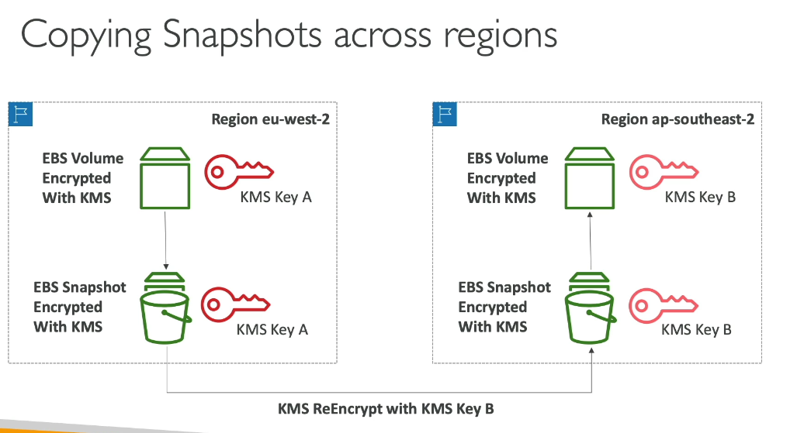As Default, KMS Keys are region specific.

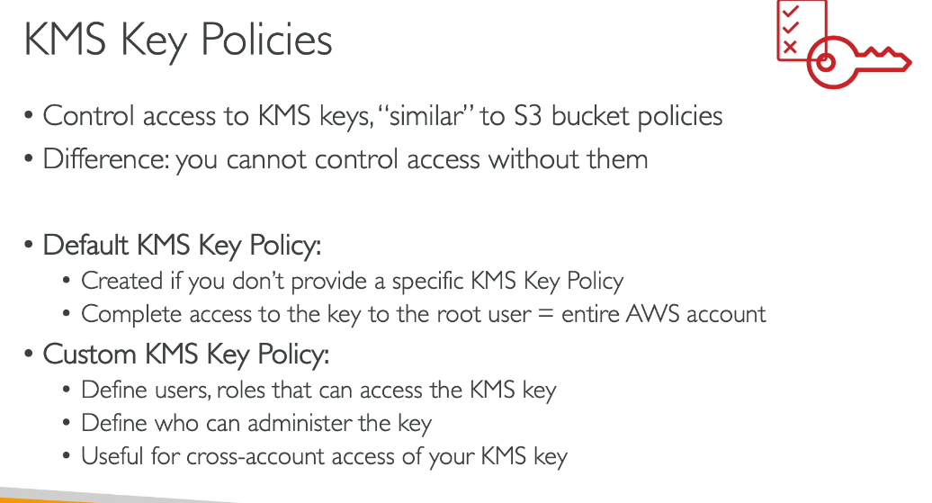

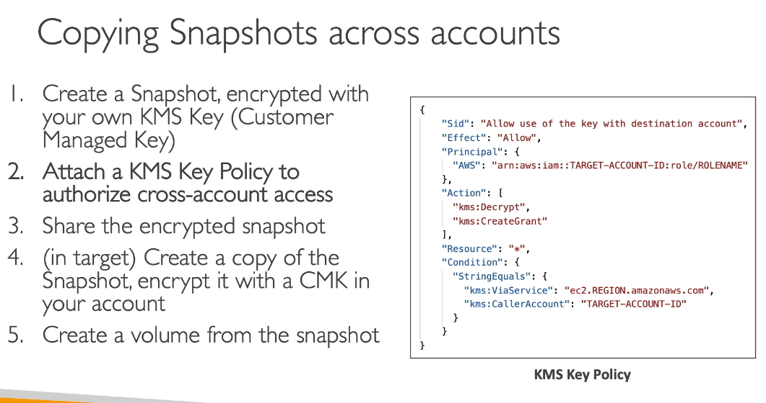

**Encrypt and Decrypt a File steps:**

|  |  |  |
| --- | --- | --- |
| **Step** | **What Happens** | **Why** |
| Encrypt with KMS | File → Encrypted ciphertext (binary) | KMS protects data |
| Base64 encode | Binary → ASCII readable characters | So you can store/transport it safely |
| Base64 decode | ASCII → Binary ciphertext | Because KMS expects real ciphertext, NOT Base64 text |
| Decrypt with KMS | Binary → Original plaintext | KMS gives back your data |

AWS-CLI Commands for the above steps

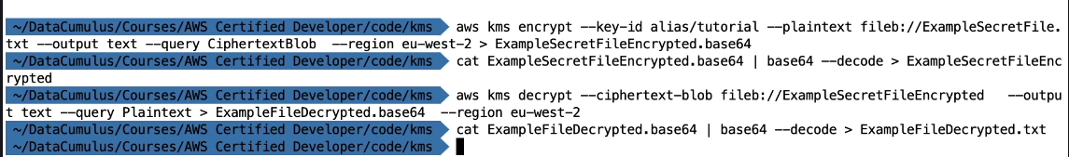

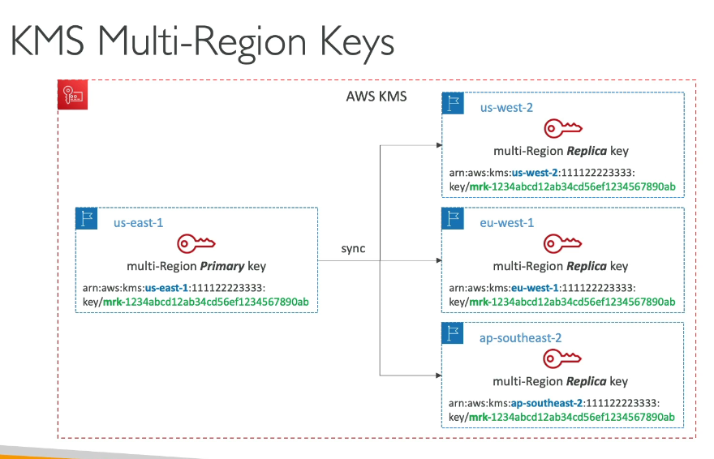

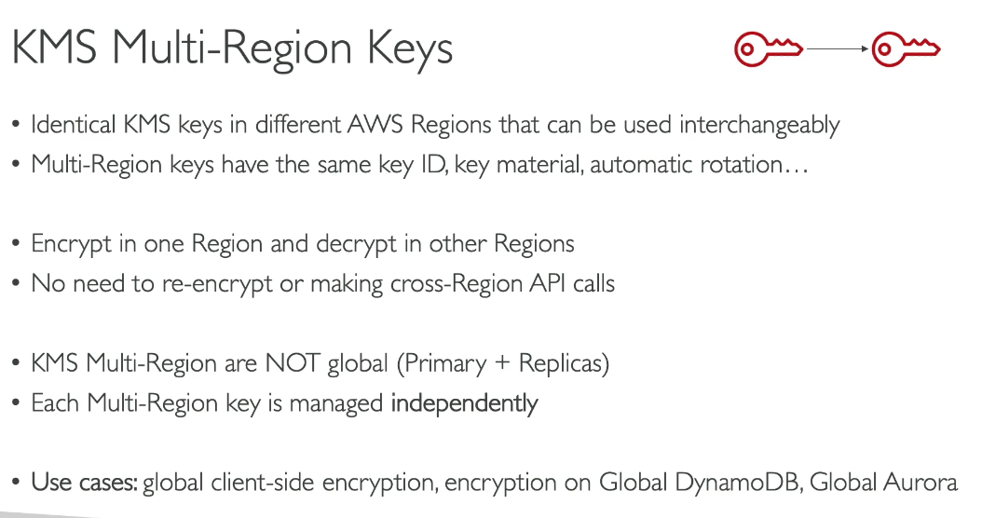

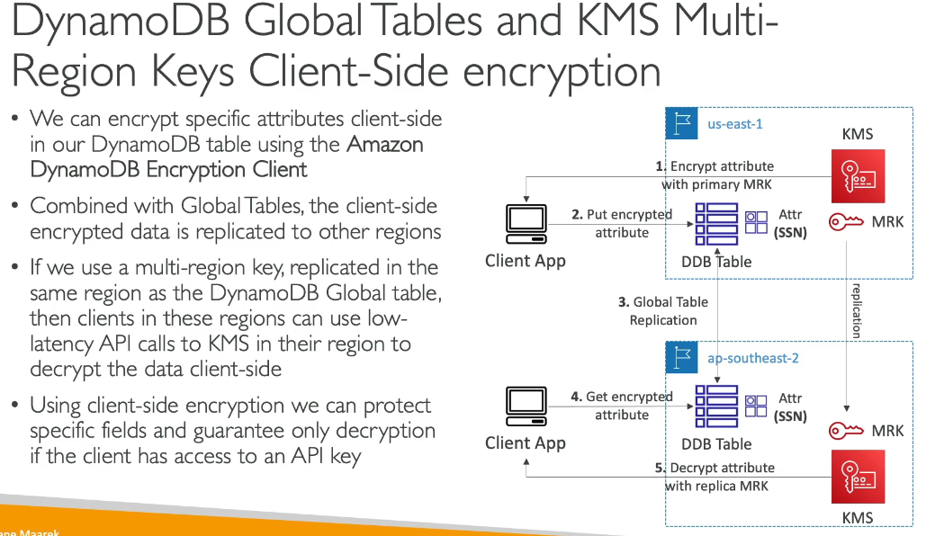

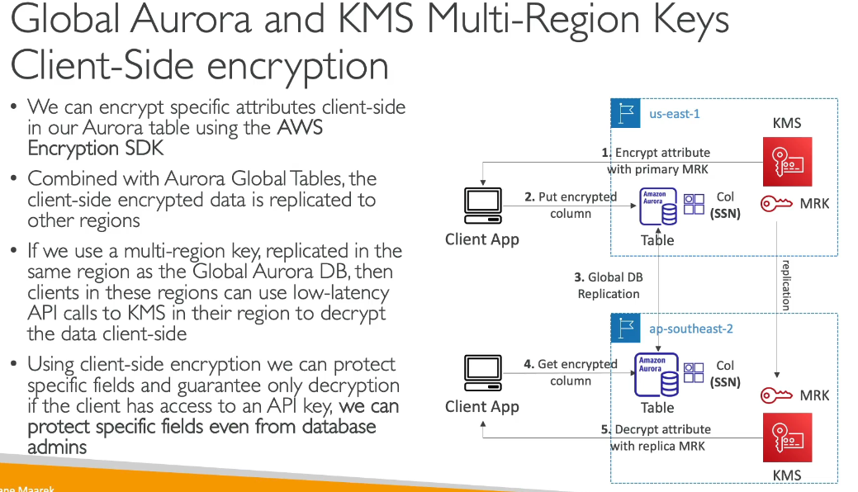

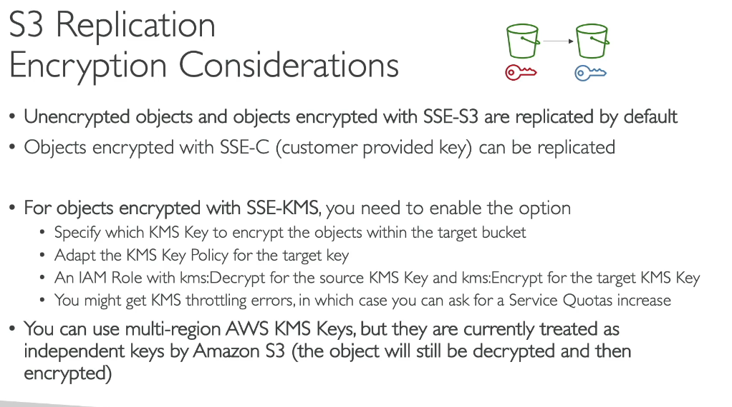

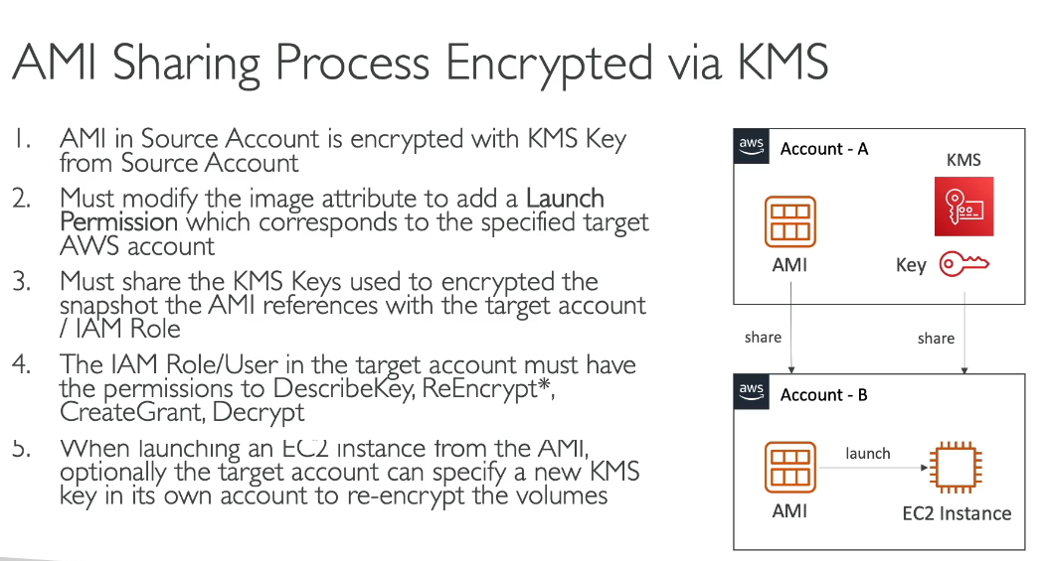

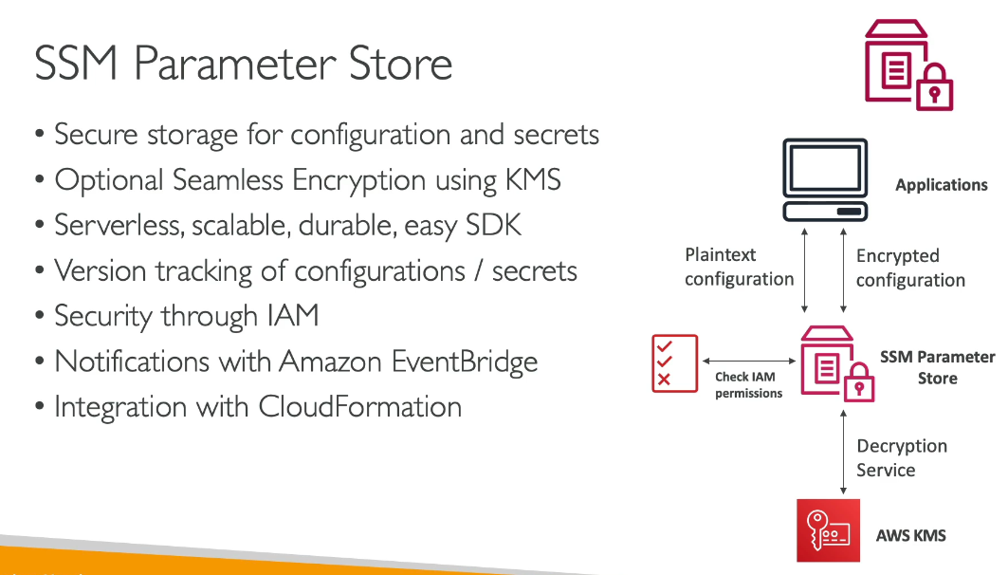

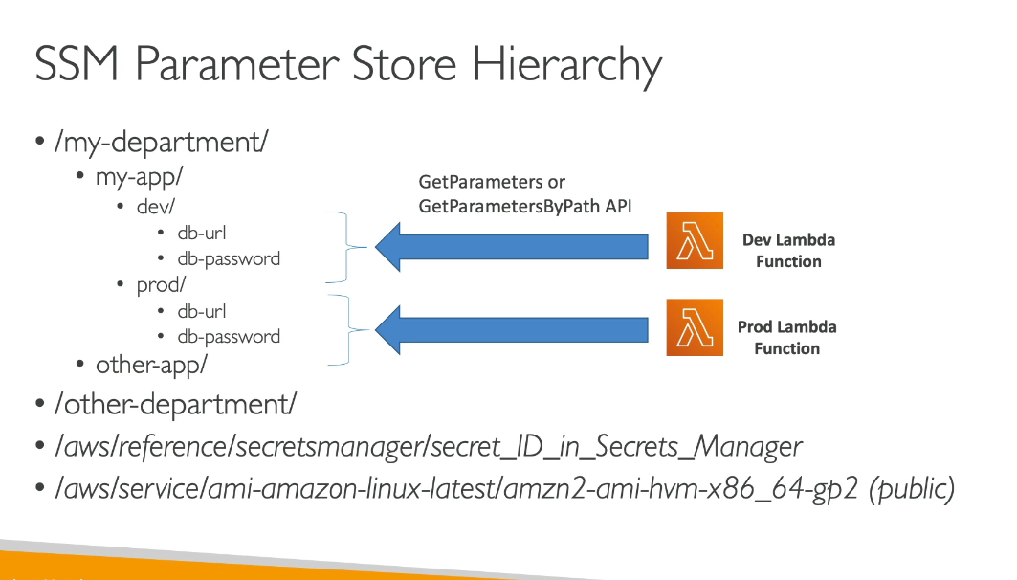

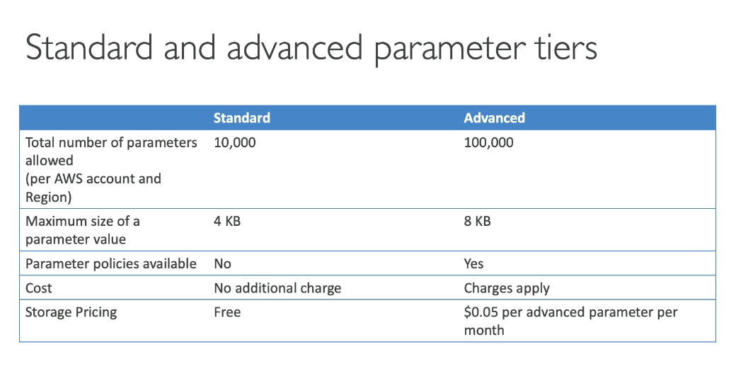

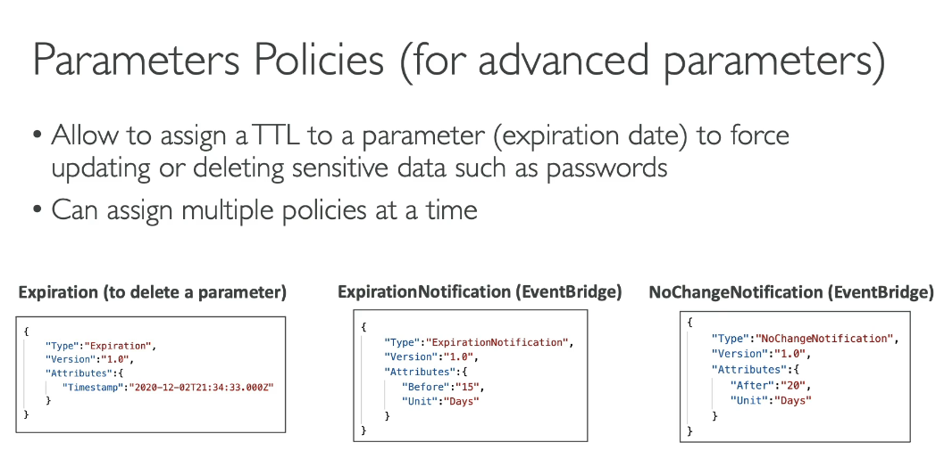

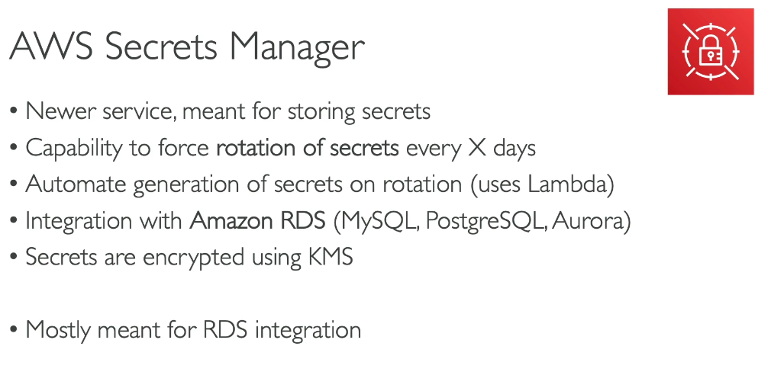

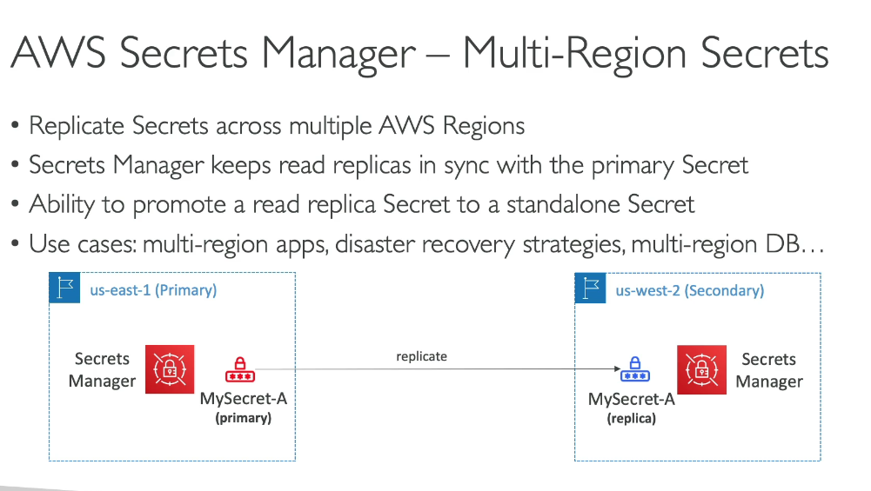

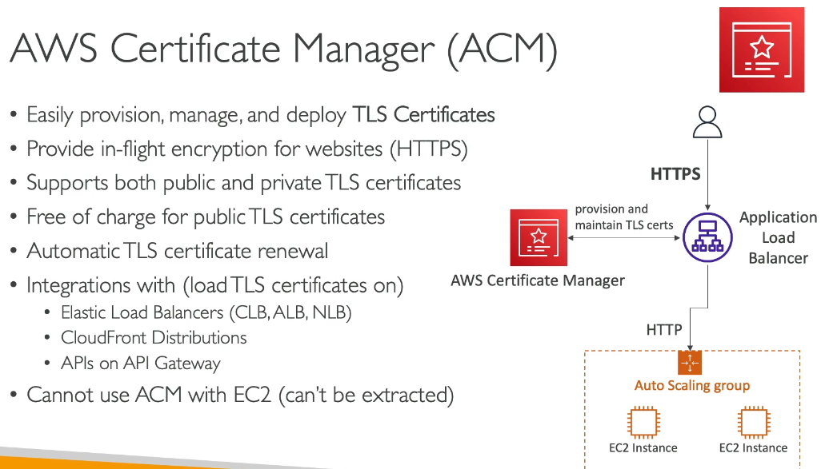**Cannot be used with individual EC2**

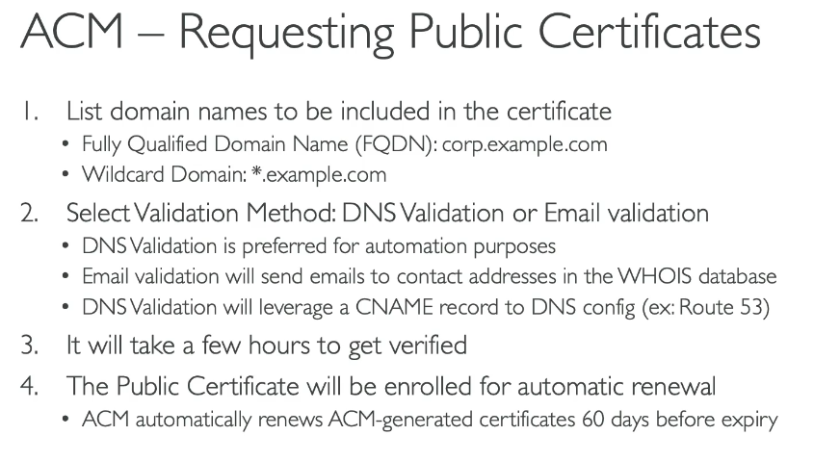

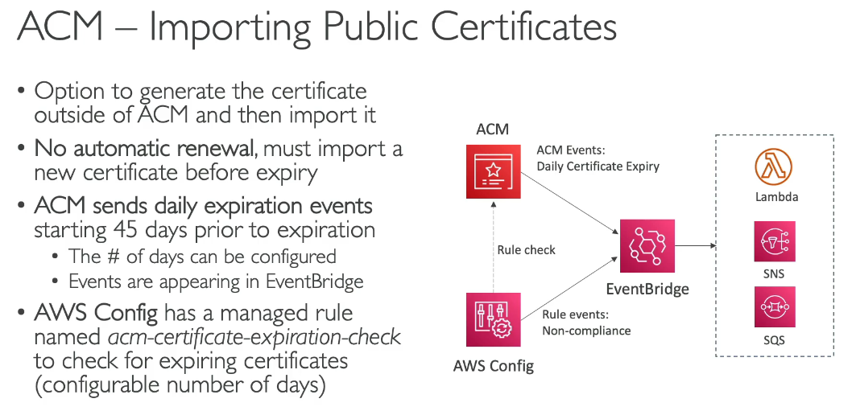

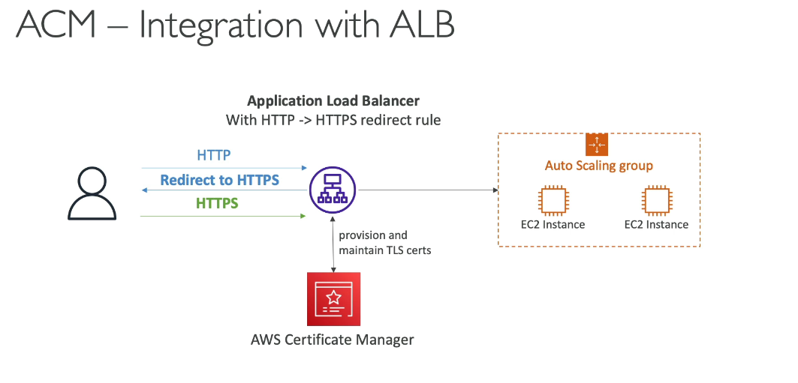

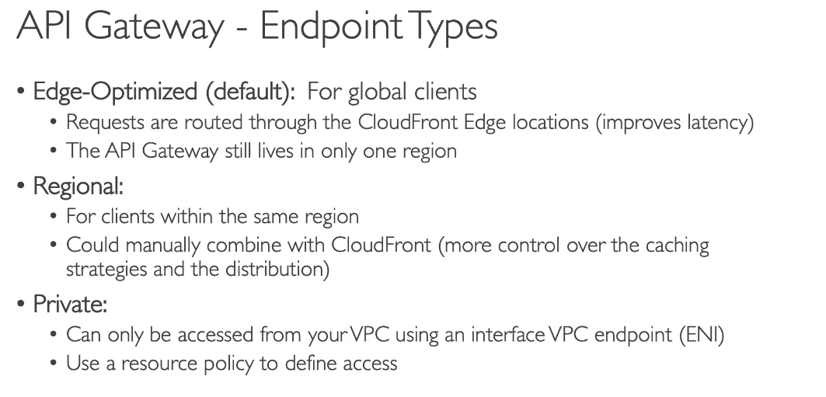

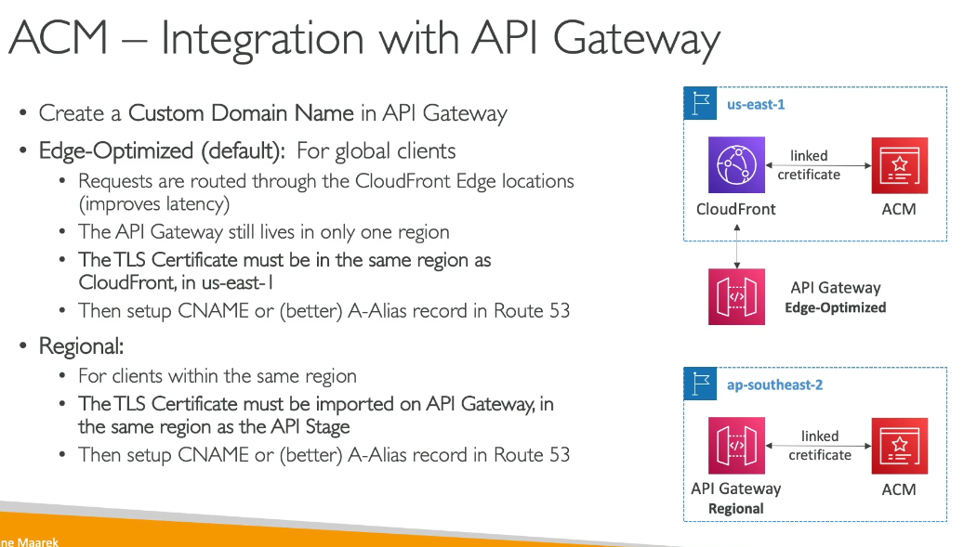

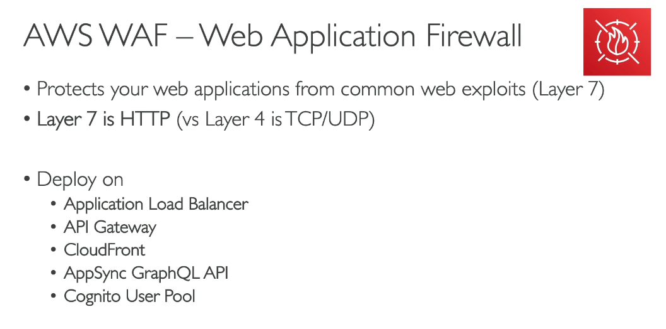**We cannot implement WAF for NLB, because it is at Layer 4, and the WAF works in Layer 7.**

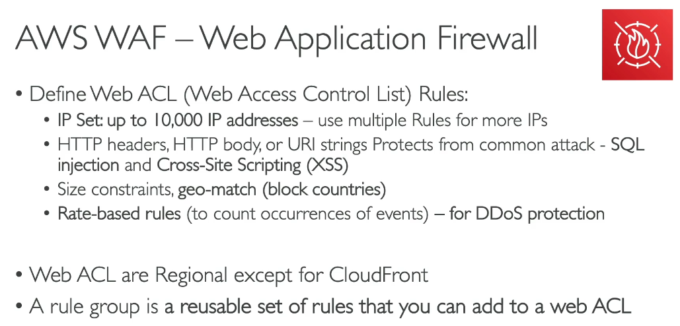

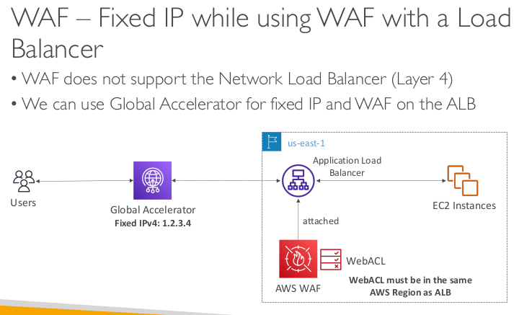

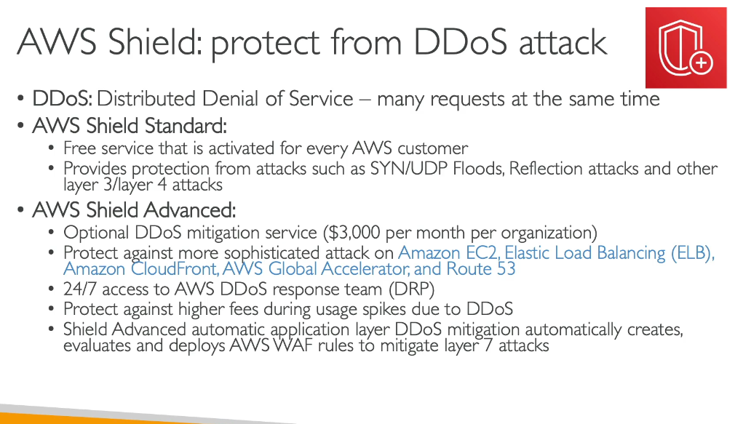

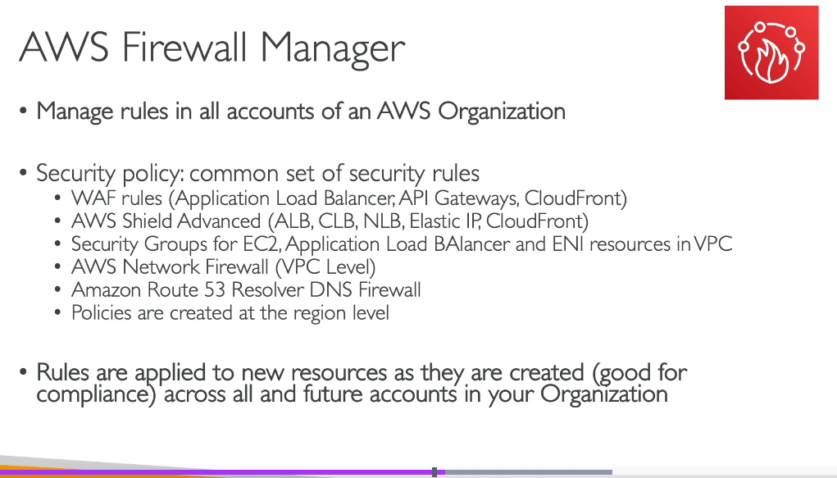

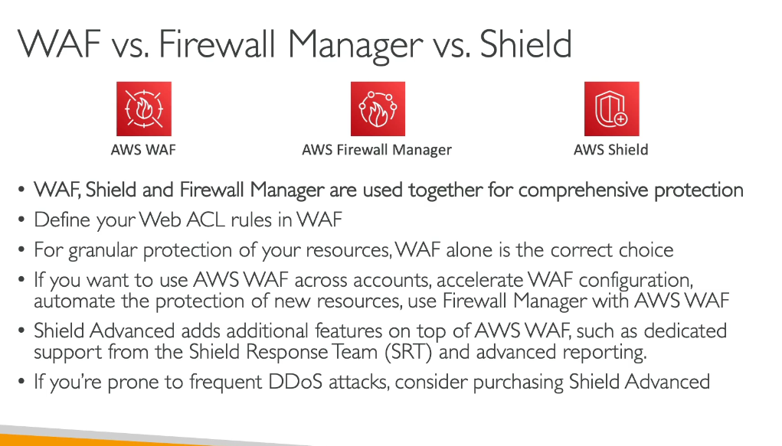

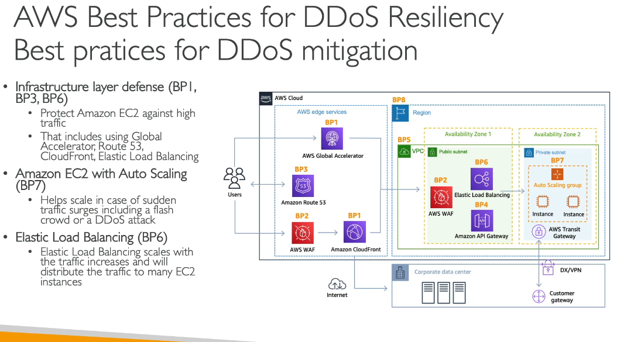

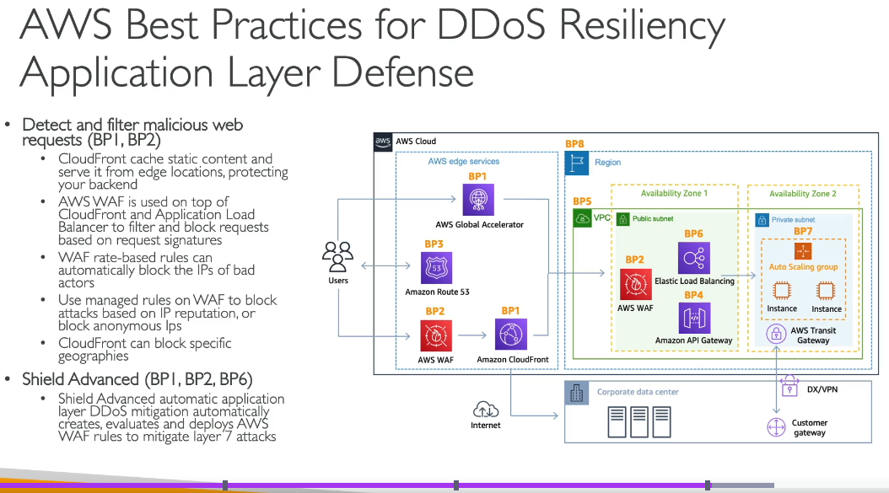

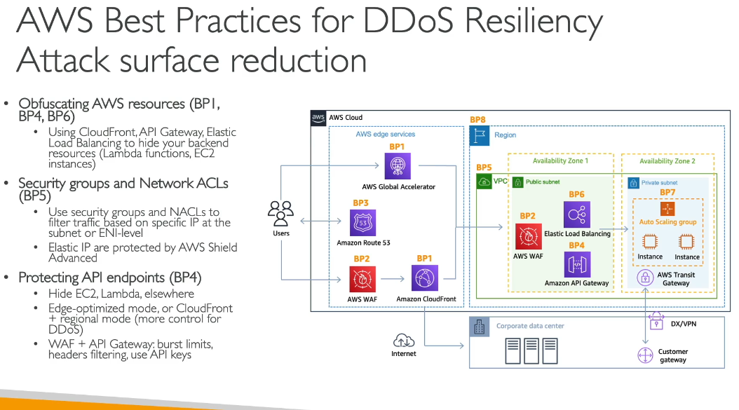

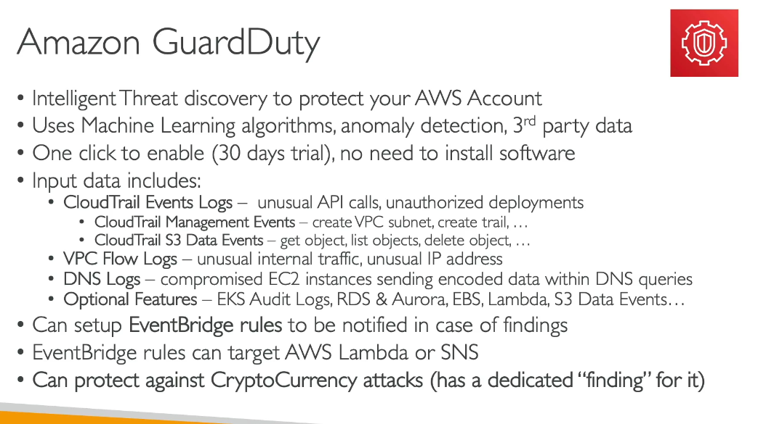

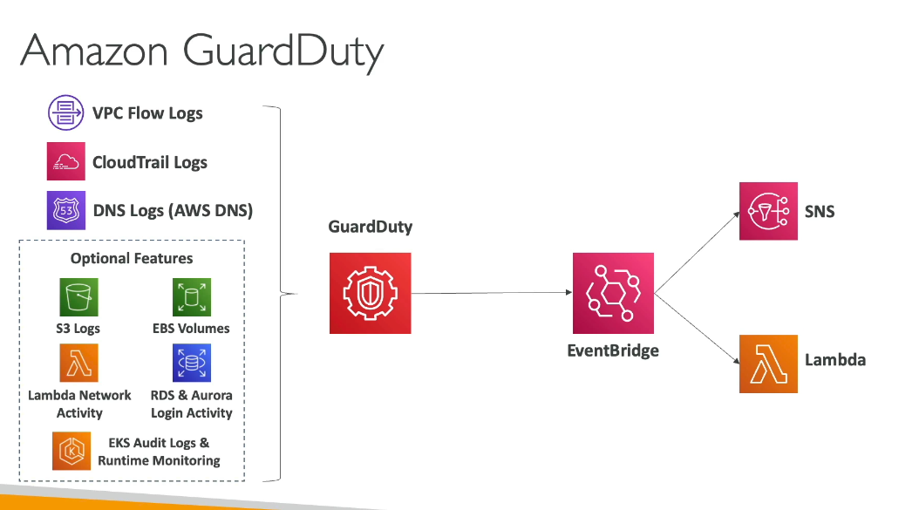

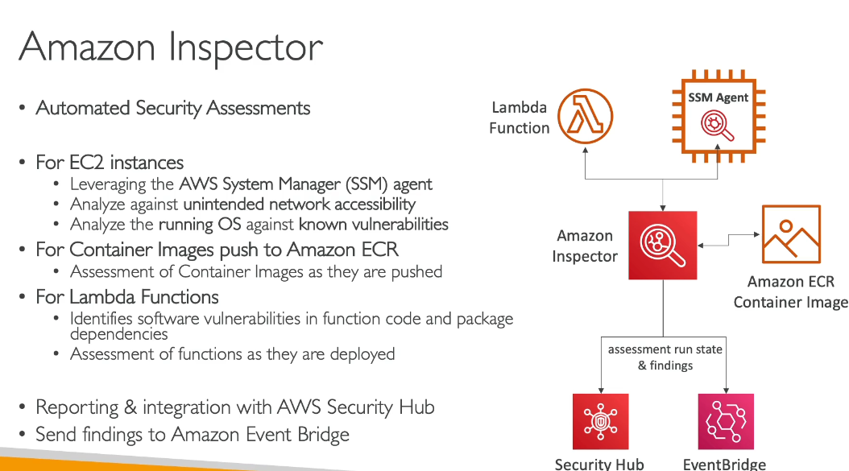

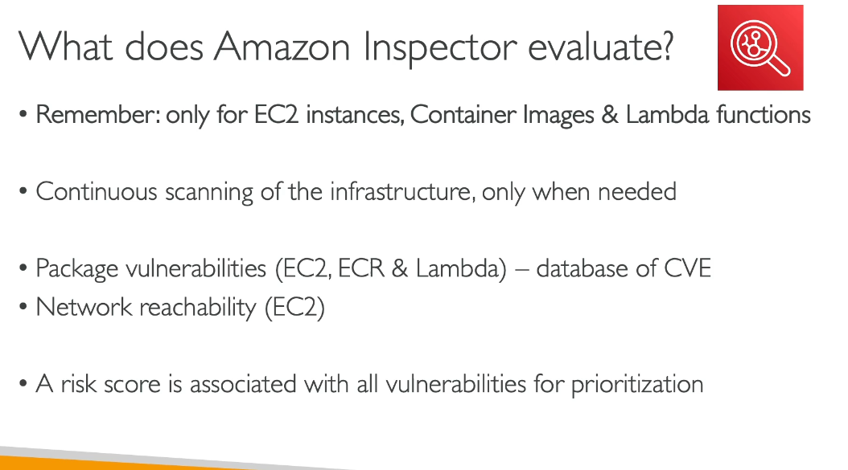

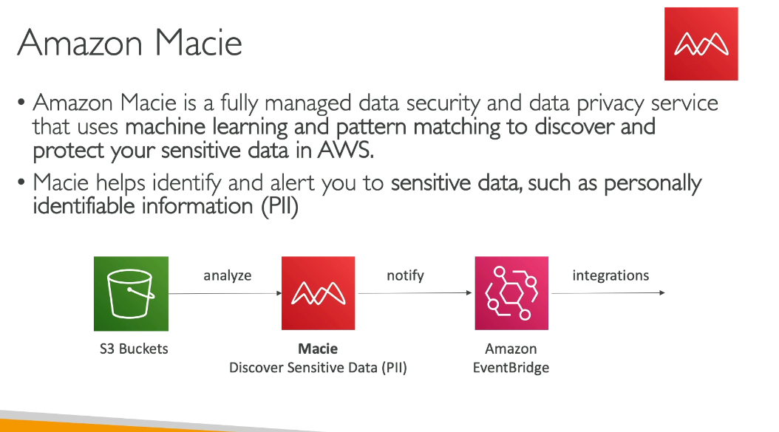

QUIZ:

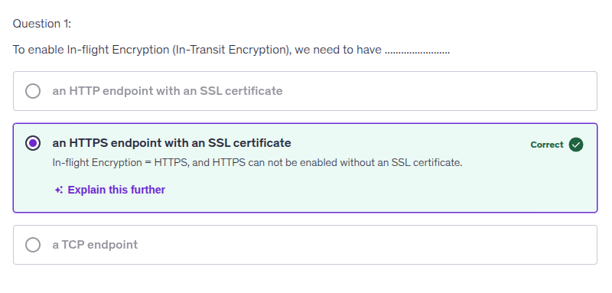

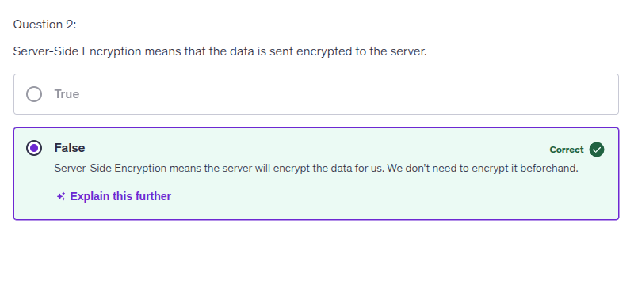

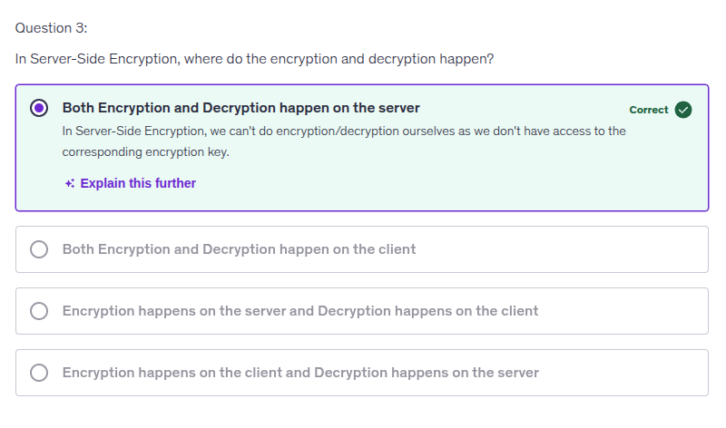

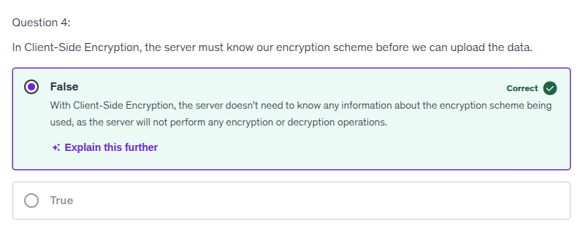

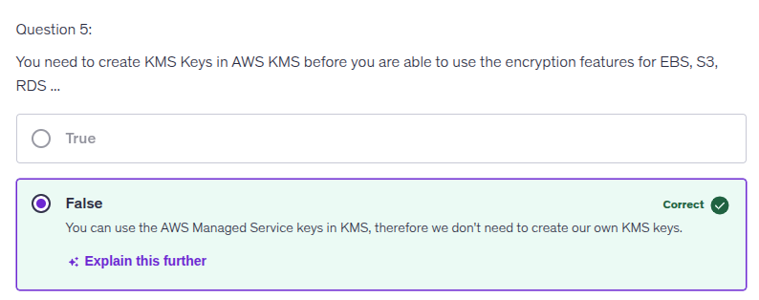

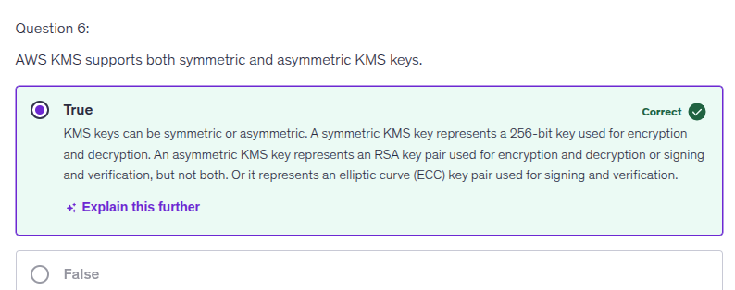

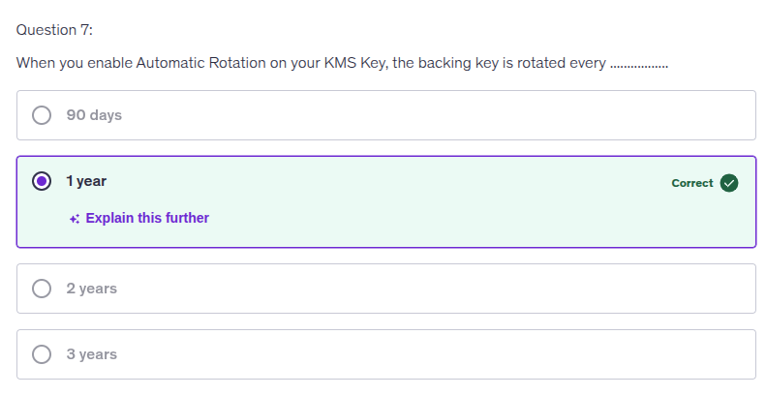

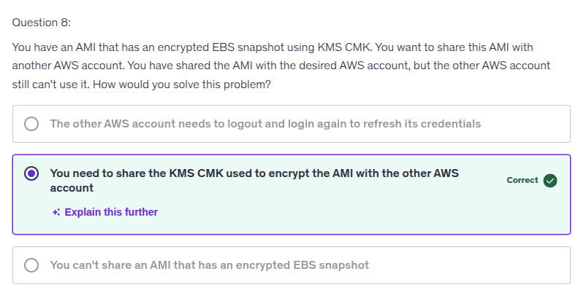

You selected the correct answer because when an AMI is encrypted with a KMS Customer Master Key (CMK), that key must be shared with any AWS account that you want to grant access to the AMI. This ensures that the other account can decrypt the snapshots and use the AMI without issues.

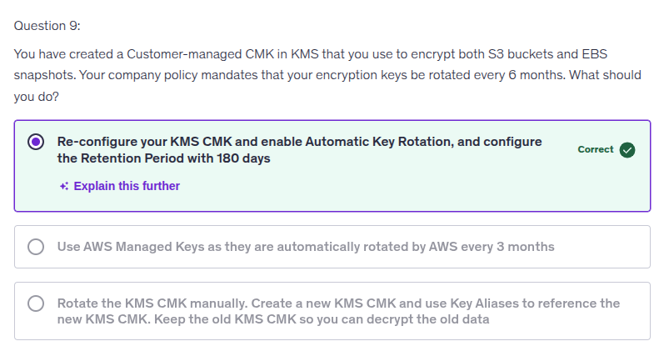

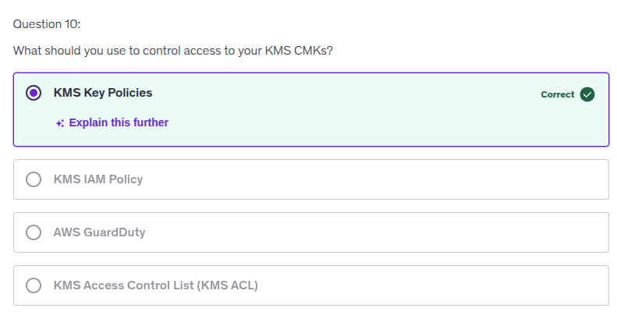

Yes — **you can use IAM with KMS**, but **IAM alone is useless without the KMS key policy**.  
 This is one of those AWS things people half-understand and then screw up.

Let’s be precise.

## **The non-negotiable rule (burn this into your brain)**

**A KMS CMK is controlled FIRST by its key policy.**  
 **IAM permissions are evaluated ONLY if the key policy allows them to matter.**

If the key policy doesn’t allow an action → **IAM can’t override it**. Ever.

## **How access to a KMS CMK is actually evaluated**

When a principal tries to use a CMK, AWS checks **both**:

1. **KMS Key Policy** (mandatory)
2. **IAM Policy** (optional, additive)

### **Effective permission = Key Policy ∩ IAM Policy**

Not OR. **AND**.

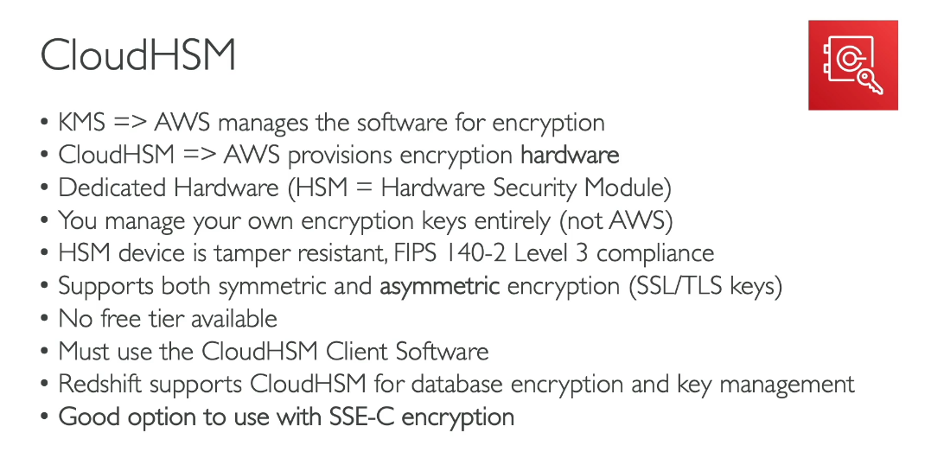

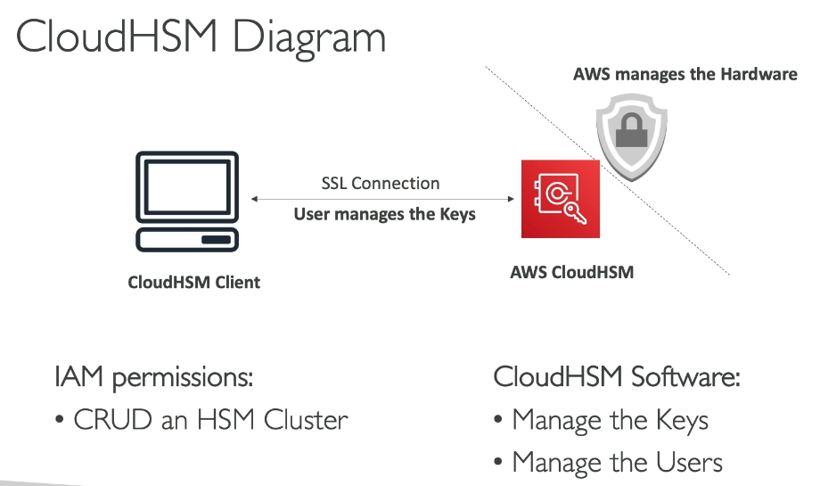

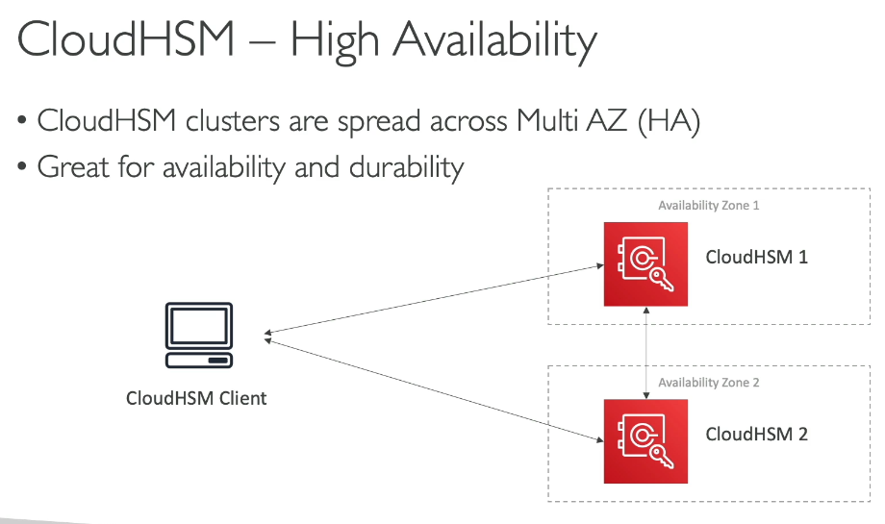

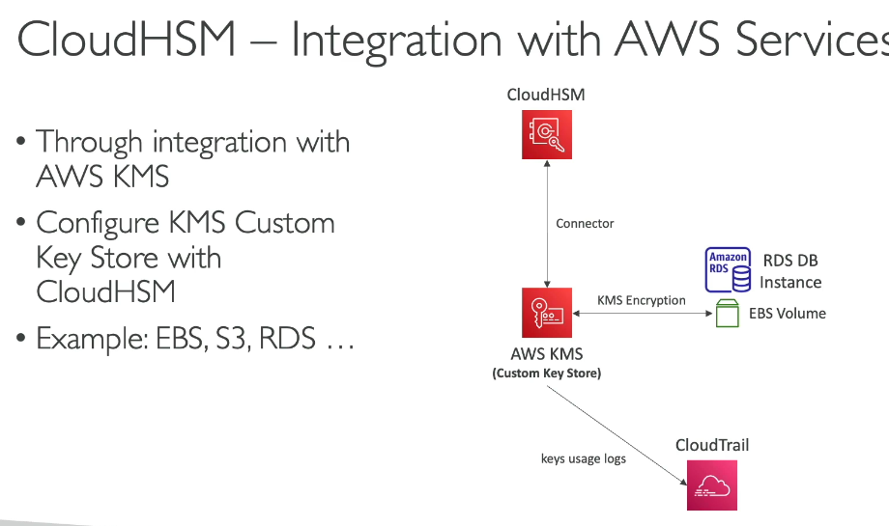

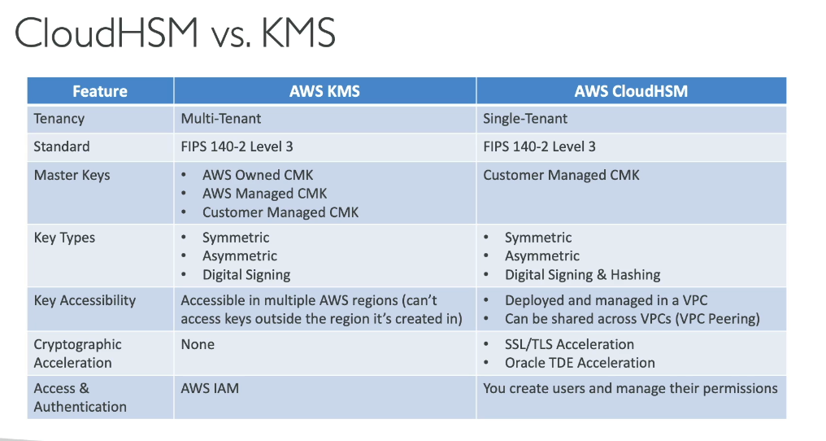

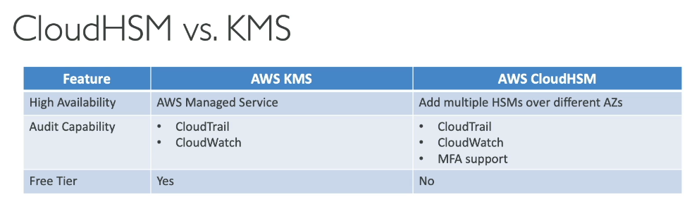

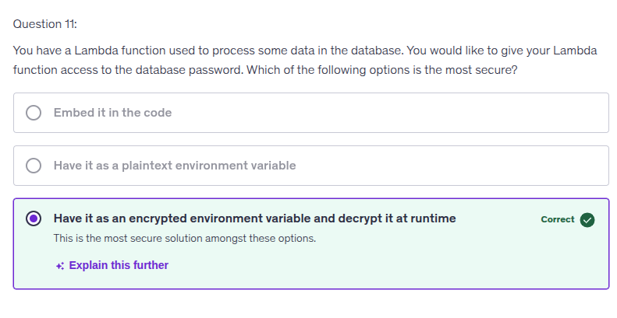

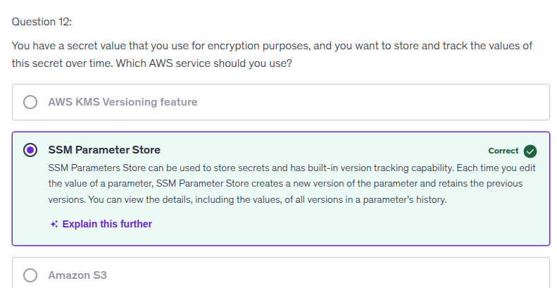

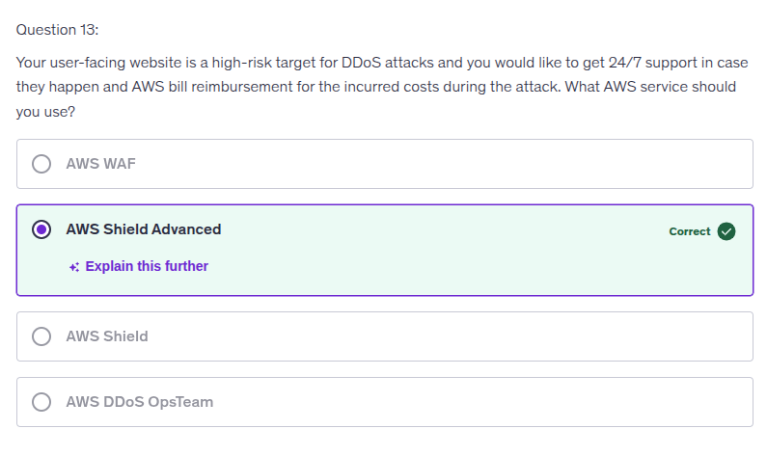

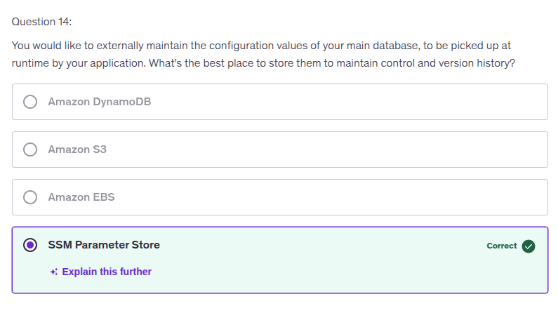

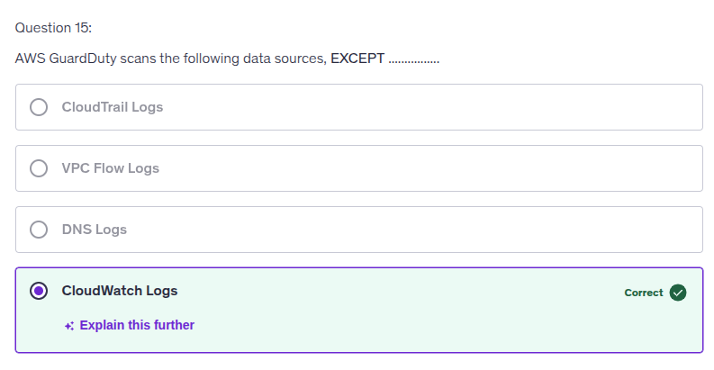

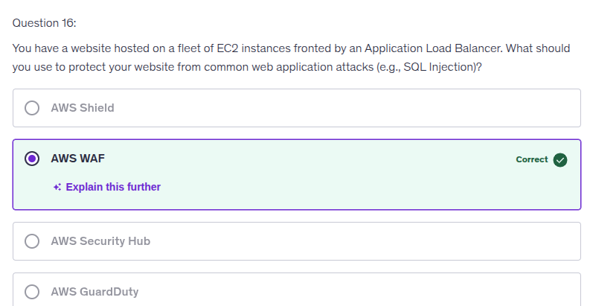

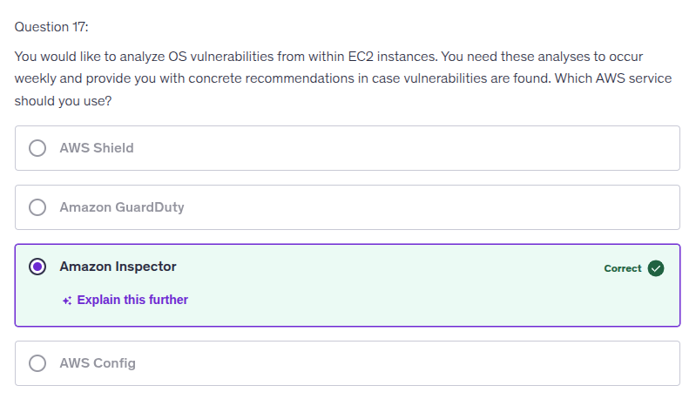

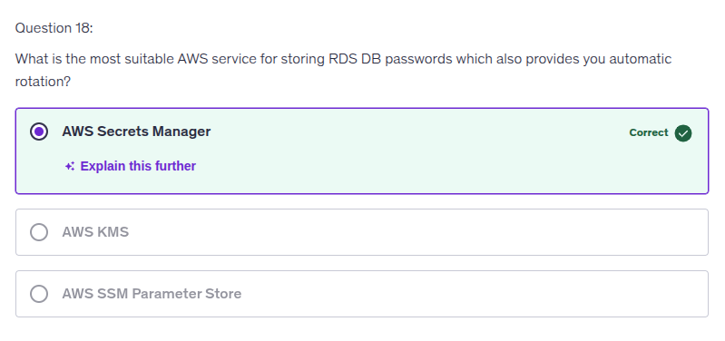

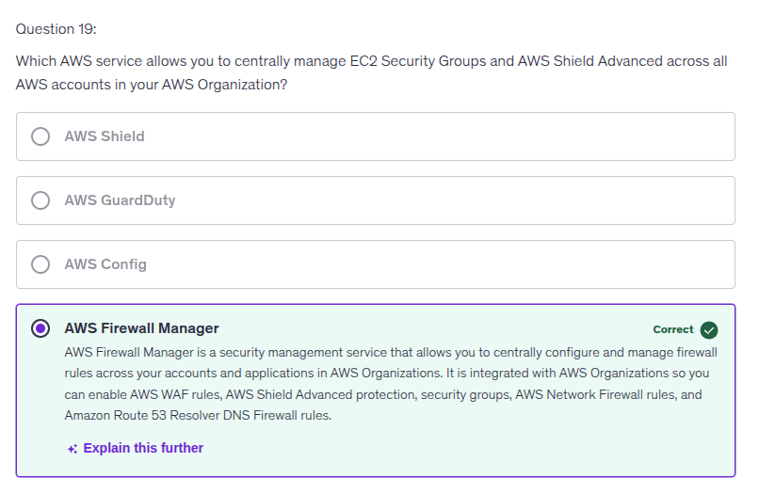

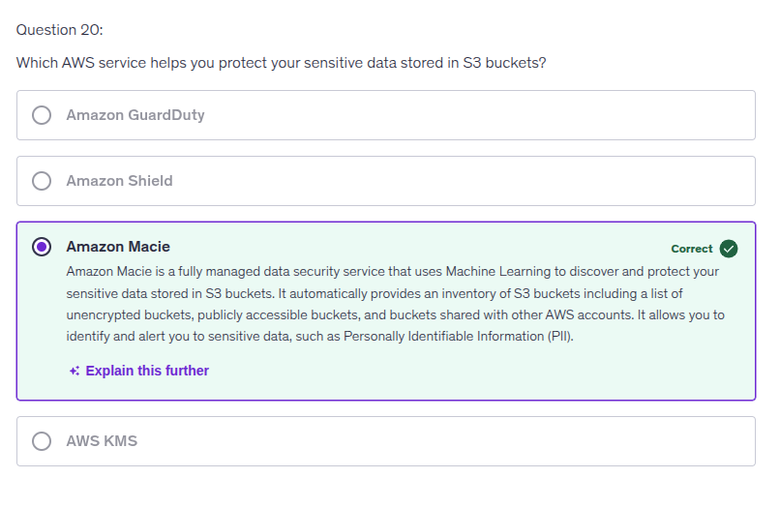

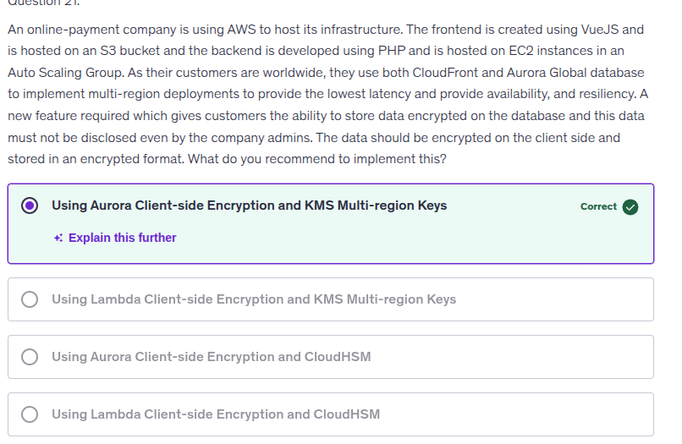

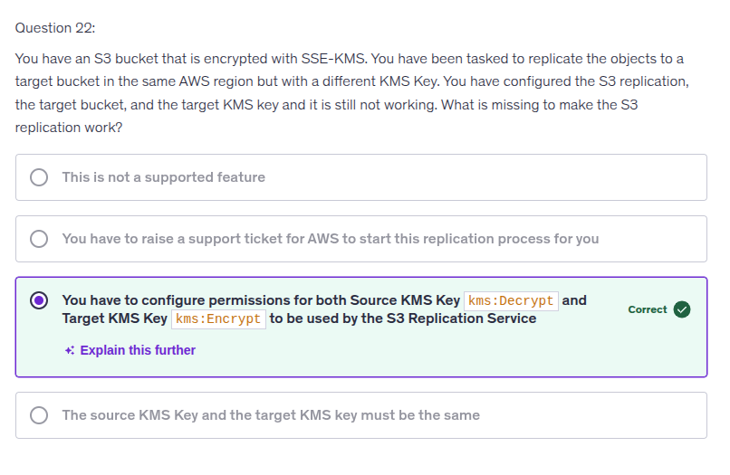

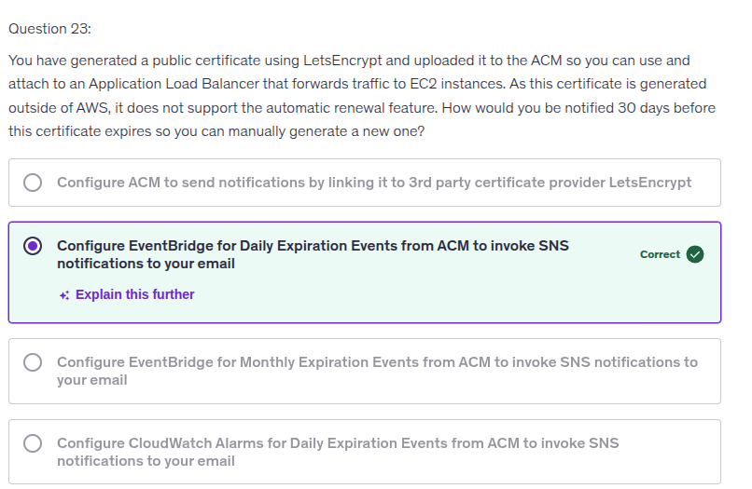

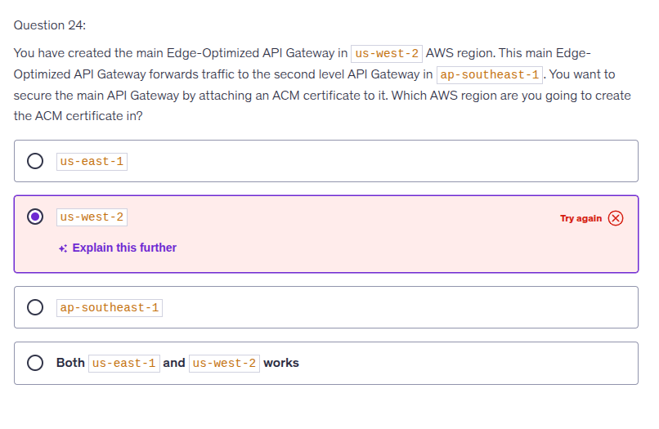

The answer choice 'us-west-2' is incorrect because the ACM certificate for an Edge-Optimized API Gateway must be created in the 'us-east-1' region. This is due to the way Edge-Optimized APIs function; they utilize AWS CloudFront, which requires certificates to be issued from 'us-east-1' for global use. Understanding this aspect of API Gateway design can help clarify why region selection is critical for effectively securing your API. Keep studying these regional requirements to enhance your knowledge!

Was this content relevant to you?

